20170307
# In the beginign was follow task.
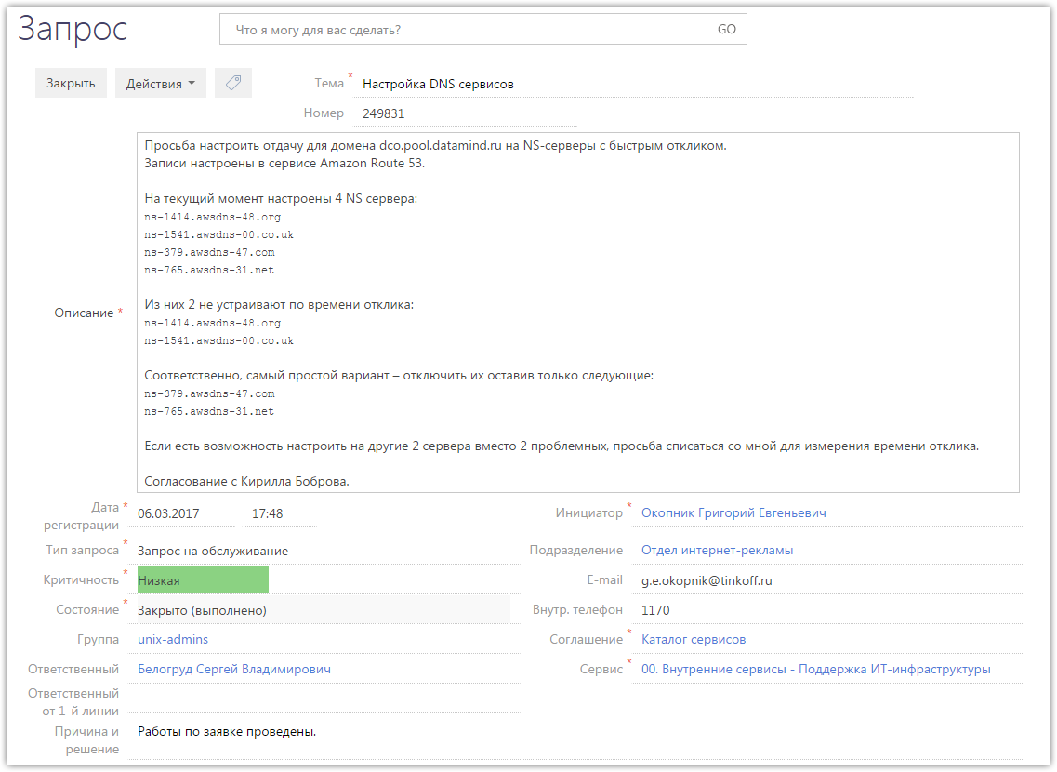

# To start I’ve connected to amazon console.
https://tinkoff.signin.aws.amazon.com/console

# Here was entered appropriate username and password.
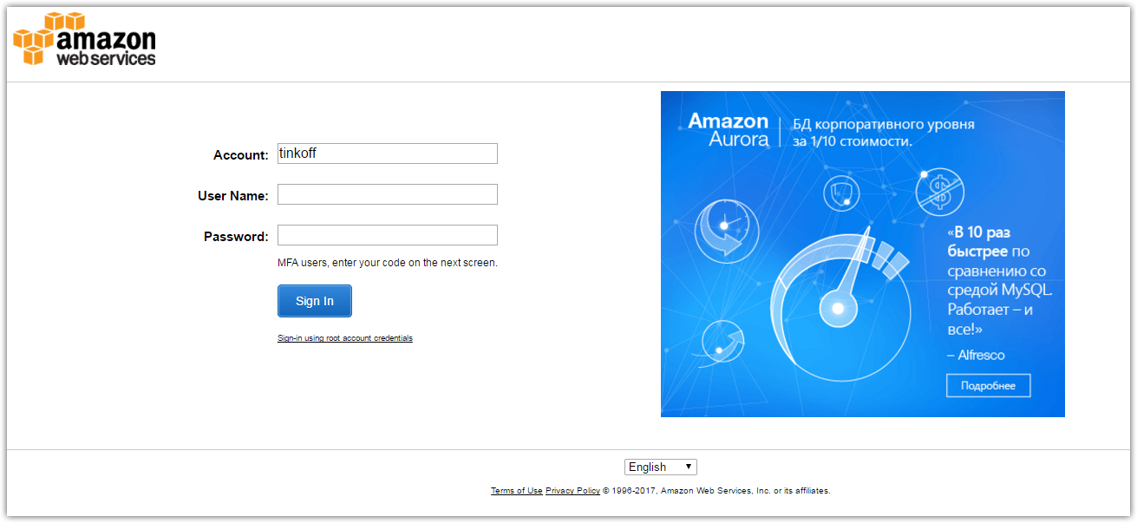

# Next was choosen “Route 53” service.
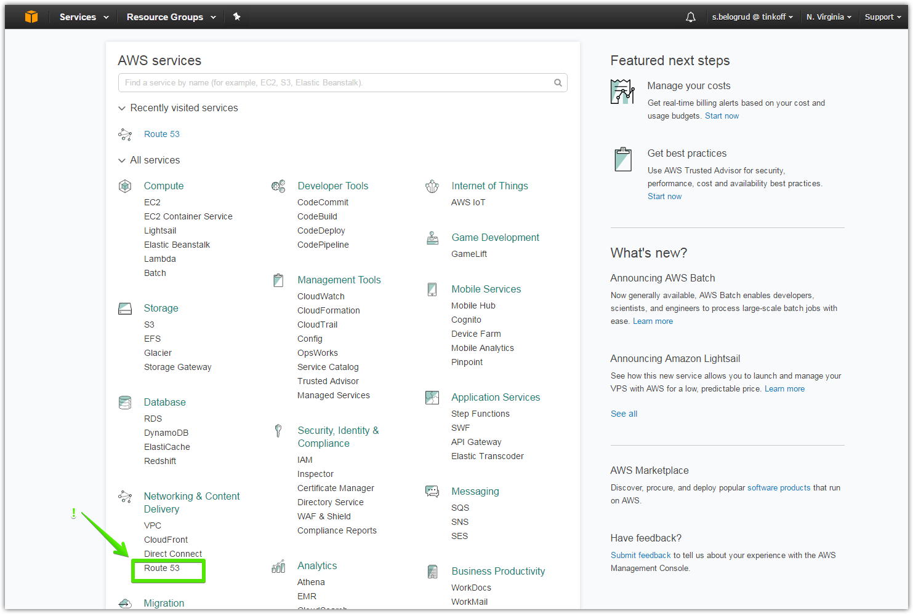

# Then was choosen group “DNS management” and link “Hosted zones” in it.
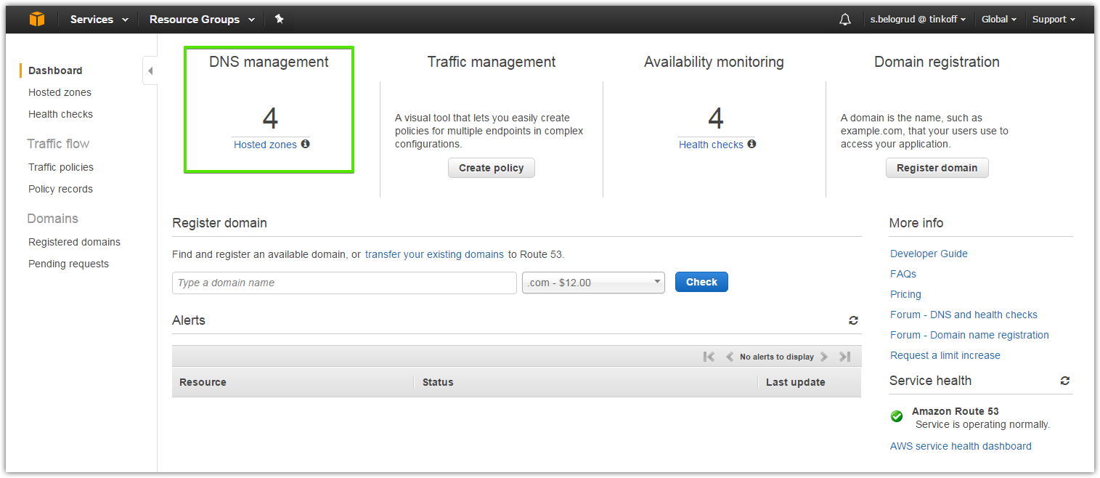

# Because into service desk task was mentioned “datamind.ru” domain, I’ve choosen it here.
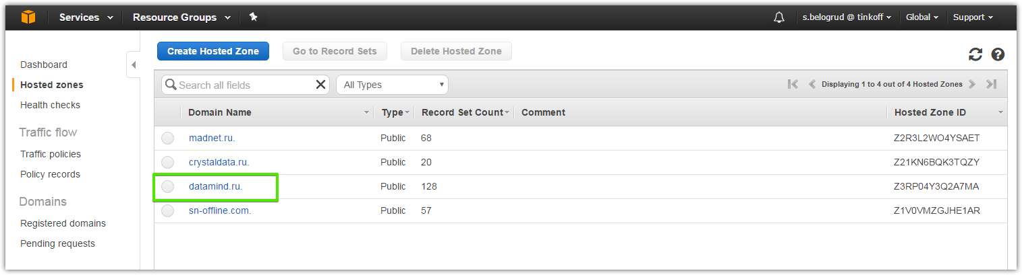

# As we can see below, there are four ns-records of ns-servers, that serve zone “datamind.ru”.
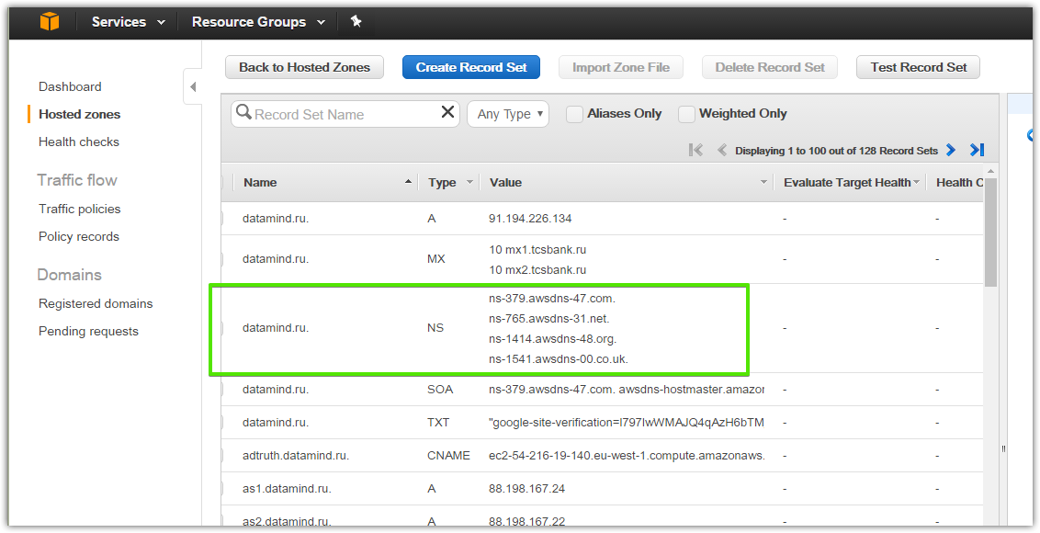

# I’ve checked appropriate field at left side of table.
# Then at right side become available fields, that would be changed.
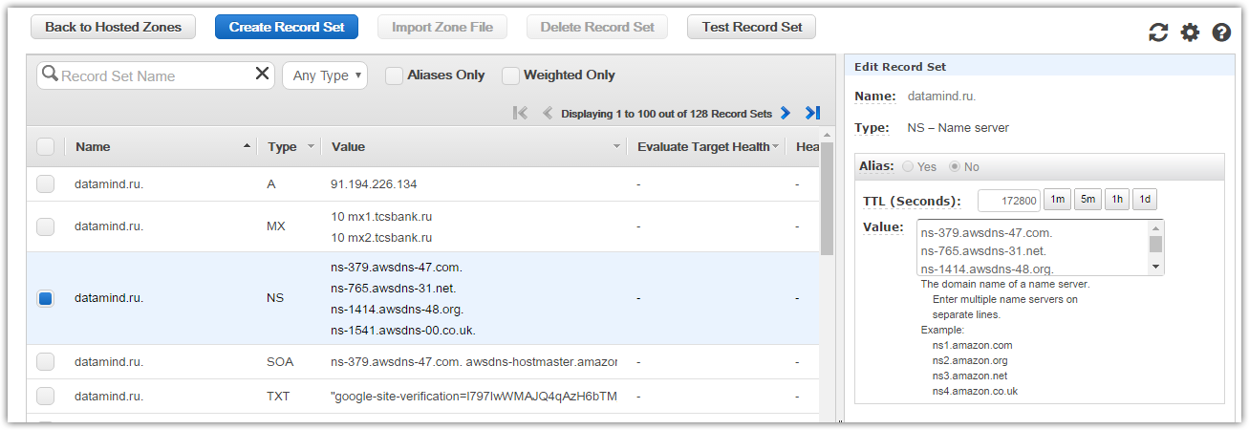

# Two records were removed from main field, because it was slow ns-servers, as it was written in service desk task.
# My changes was saved with pressed button below changed fields (in this picture it was not shown).
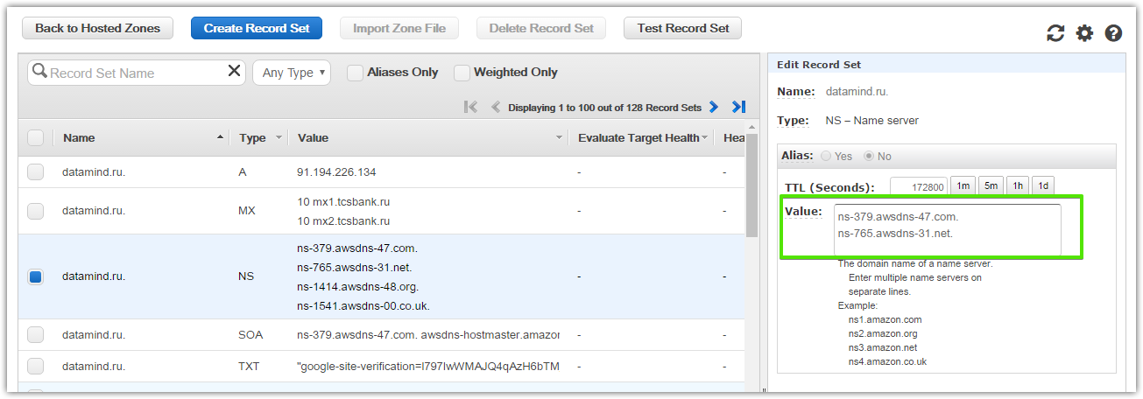

# After that, I have seen follow.
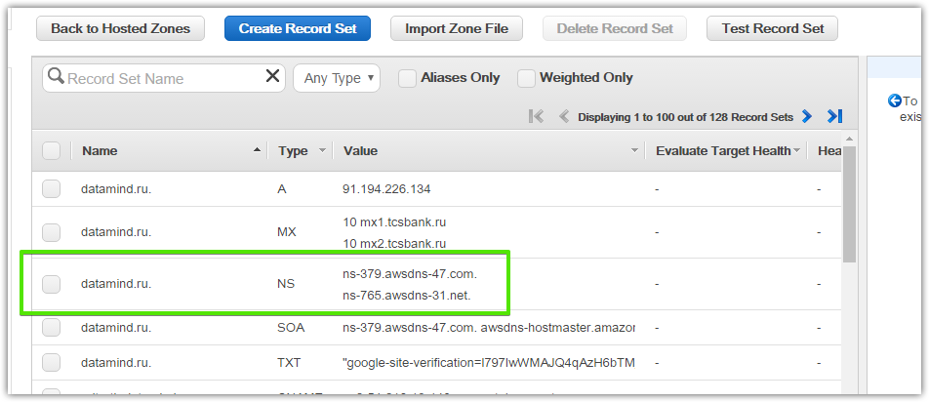

# Next step I was tested how works dns-names resolving after my changes.
# I’ve connected to server bk1.datamind.ru.
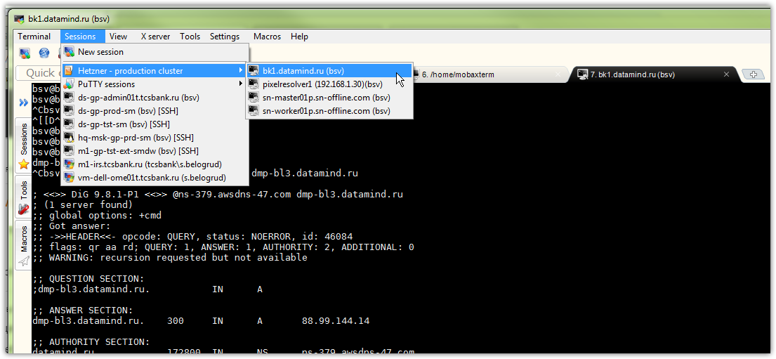

# And then start tests with dig utility.
# Lists of servers would be taken from amazon in that web-page, where I had changed list of ns-servers.
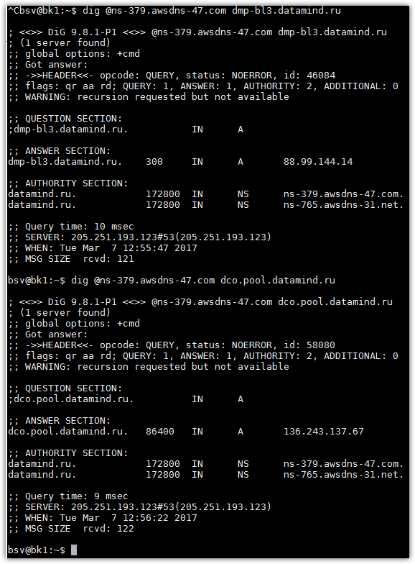

# Follow is a info about what amazon’s route 53 service is.
https://aws.amazon.com/ru/route53/

